**Agent Performance Dashboard – Documentation**

**Purpose**

This interactive dashboard was developed to visualize prediction results, track agent performance trends, and generate smart, personalized action plans for at-risk agents. It allows users to quickly identify underperforming agents and take targeted action based on real-time data insights.

**Key Features**

**1. Agent Prediction Overview**

* The homepage displays a color-coded list of all agents.
* **Green** indicates agents predicted to perform well (not NILL).
* **Red** indicates agents predicted to underperform (NILL).
* This provides a clear, instant view of which agents may need intervention.

**2. Agent Profile View**

Clicking on any agent code opens a detailed view that includes:

* A **line graph** showing the agent’s monthly policy trend.
* A summary of the agent’s current stats, including:
  + Agent ID and age
  + Join month
  + Number of proposals
  + Number of quotations
  + Number of customers
  + ANBP (Annualized New Business Premium)

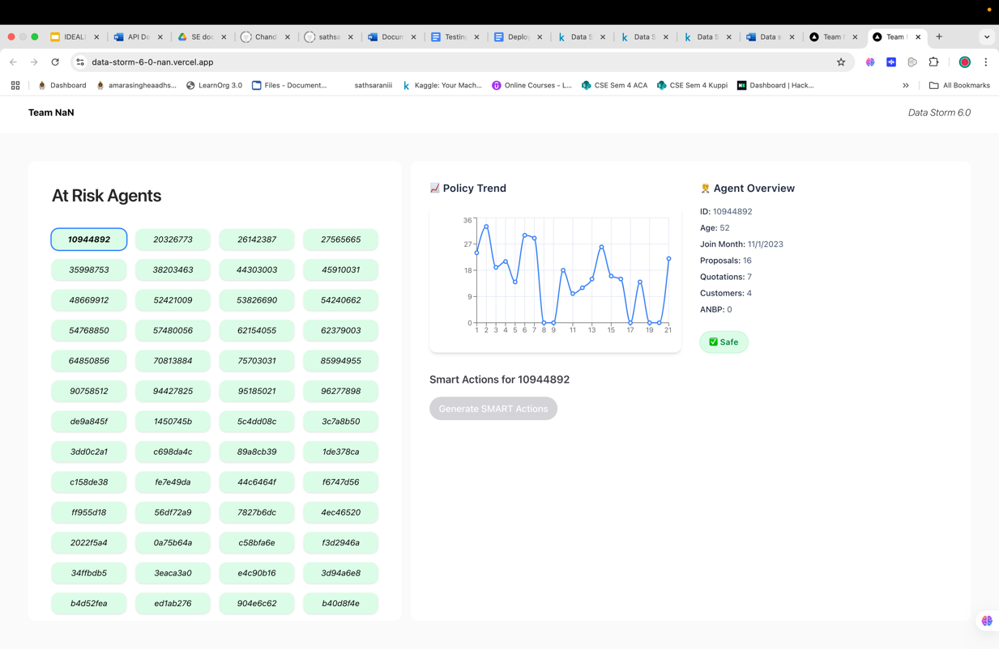

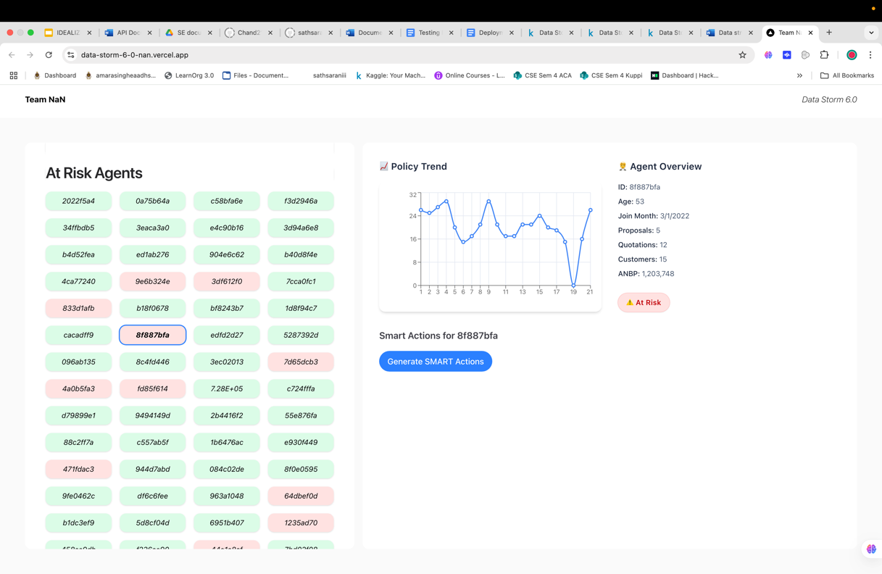

**3. Smart Action Generator**

* If an agent is flagged as at risk (shown in red), a **“Generate Smart Actions”** button appears.
* Clicking this button produces 3 personalized SMART recommendations to improve performance, categorized into:
  + Training
  + Mentoring
  + Goal Setting or Motivation

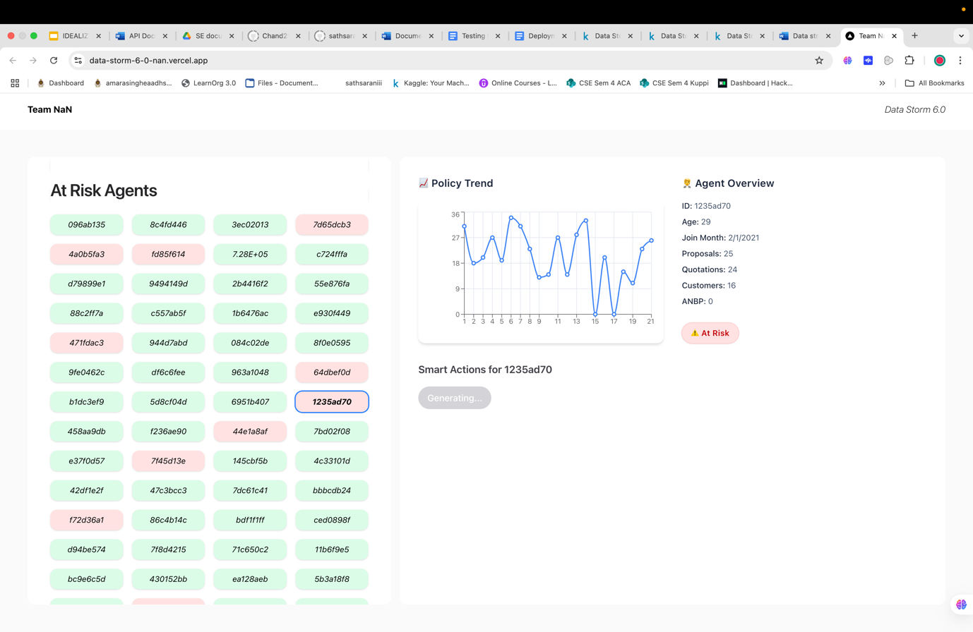

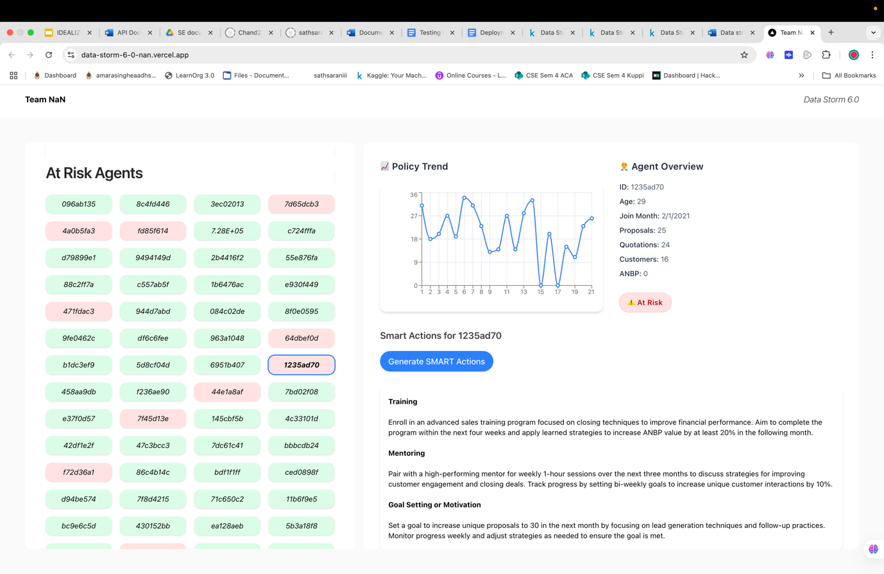

**Technology Stack**

* **Frontend**: Next.js, Tailwind CSS, TypeScript
* **Prompting/AI Integration**: OpenAI GPT-4 API
* **Model Integration**: Backend predictions from our trained classification model

**Smart Action Generation Logic**

The smart action generator is powered by a custom prompt sent to **OpenAI’s GPT-4o API**.

Here’s how it works:

* When an agent is predicted to become NILL (i.e., to sell no policies in the upcoming month), their current performance metrics are passed into a prompt.
* The model compares these metrics with the average stats of **high-performing agents**, such as:
  + Mean Unique Proposals: 19.43
  + Mean Quotations: 14.54
  + Mean Customers: 15.08
  + ANBP Value: 1,242,402.98
* Based on the comparison, the API returns three concise, SMART recommendations across three areas:
  1. **Training**
  2. **Mentoring**
  3. **Goal Setting or Motivation**

These suggestions are immediately shown on the dashboard and can be used by managers for fast, targeted intervention.

**Link to the dashboard**

You can access the dashboard here: <https://data-storm-6-0-nan.vercel.app/>